a)

Given that:

$$x\left(t\right)=\left\{\begin{aligned}4, 0≤t≤6 \\ -2, -4≤t<0 \\ 0, othewise\end{aligned}\right.$$

$$E_{x}=\int_{-∞}^{+∞}{{\left|x\left(t\right)\right|}^{2}dt}=\int_{0}^{6}{{\left|4\right|}^{2}dt}+\int_{-4}^{0}{{\left|-2\right|}^{2}dt}=112$$

We have: $x\left(t\right)=4\left(u\left(t\right)-u\left(t-6\right)\right)+\left(-2\right)\left(u\left(t+4\right)-u\left(t\right)\right)$

$$=-2u\left(t+4\right)+6u\left(t\right)-4u\left(t-6\right)$$

*(Reader sketches the signal by yourself)*

b)

Given that: $x\left[n\right]={0.5}^{n}u\left[n\right]$

$$E_{x}=\sum_{n=-∞}^{+∞}{{\left|x\left[n\right]\right|}^{2}}=\sum_{n=0}^{+∞}{{\left|{0.5}^{n}\right|}^{2}}=\sum_{n=0}^{+∞}{{0.25}^{n}}=\frac{4}{3}$$

a) Given that:

1. Check for linearity:

$$Let: \left\{\begin{aligned}x_{1}\underset{→}{S}y_{1}=x_{1}\left(2t-1\right)+x_{1}\left(t\right) \\ x_{2}\underset{→}{S}y_{2}=x_{2}\left(2t-1\right)+x_{2}\left(t\right)\end{aligned}\right.$$

$$→a_{1}y_{1}+a_{2}y_{2}=a_{1}\left(x_{1}\left(2t-1\right)+x_{1}\left(t\right)\right)+a_{2}\left(x_{2}\left(2t-1\right)+x_{2}\left(t\right)\right) (1)$$

Let: $x=a_{1}x_{1}+a_{2}x_{2} \underset{→}{S}y=a_{1}x_{1}\left(2t-1\right)+a_{2}x_{2}\left(2t-1\right)+a_{1}x_{1}\left(t\right)+a_{2}x_{2}\left(t\right) (2)$

From $(1)$ and $\left(2\right)$, $a_{1}y_{1}+a_{2}y_{2}=S\left\{a_{1}x_{1}+a_{2}x_{2}\right\}$, the system is linear.

2. Check for time invariant:

Let: $x(t)\underset{→}{S}y=x\left(2t-1\right)+x(t)$

$→y\left(t-T\right)=x\left(2t-2T-1\right)+x(t-T)$ $(1)$ (delay the ouput).

Let: $x_{T}\left(t\right)=x\left(t-T\right)\underset{→}{S}y_{T}=x_{T}\left(2t-1\right)+x_{T}\left(t\right)=x\left(2t-T-1\right)+x\left(t-T\right) (2)$

Since, $\left(1\right)≠(2)$, therefore, the system is time variant.

b) Given that:

1. Check for linearity:

$$Let: \left\{\begin{aligned}x_{1}\underset{→}{S}y_{1}=3x_{1}\left(t-1\right)+2 \\ x_{2}\underset{→}{S}y_{2}=3x_{2}\left(t-1\right)+2\end{aligned}\right.$$

$$→a_{1}y_{1}+a_{2}y_{2}=a_{1}\left(3x_{1}\left(t-1\right)+2\right)+a_{2}\left(3x_{2}\left(t-1\right)+2\right) (1)$$

Let: $x=a_{1}x_{1}+a_{2}x_{2} \underset{→}{S}y=3\left(a_{1}x_{1}\left(t-1\right)+a_{2}x_{2}\left(t-1\right)\right)+2 (2)$

From $(1)$ and $\left(2\right)$, $a_{1}y_{1}+a_{2}y_{2}≠S\left\{a_{1}x_{1}+a_{2}x_{2}\right\}$, the system is nonlinear.

2. Check for time invariant:

Let: $x(t)\underset{→}{S}y=3x\left(t-1\right)+2$

$→y\left(t-T\right)=3x\left(t-T-1\right)+2 (1)$ (delay the ouput).

Let: $x_{T}\left(t\right)=x\left(t-T\right)\underset{→}{S}y_{T}=3x_{T}\left(t-1\right)+2=3x\left(t-T-1\right)+2 (2)$

Since, $\left(1\right)=(2)$, therefore, the system is time invariant.

a) Given that: $y\left[n\right]=x\left[2n\right]$

We have:

$$+ y\left[0\right]=x\left[0\right]=4$$

$$+ y\left[1\right]=x\left[2\right]=3$$

$$+ y\left[2\right]=x\left[4\right]=3$$

$$+ y\left[3\right]=x\left[6\right]=5$$

Therefore, $y\left[n\right]=\left[4, 3, 3, 5\right]$

Let: $x\left[n\right]\underset{→}{S}y[n]=x[2n]$

$→y[n-N]=x\left[2n-2N\right]$ $(1)$ (delay the ouput).

Let: $x_{N}[n]=x[n-N]\underset{→}{S}y_{N}=x_{N}[2n]=x\left[2n-N\right] (2)$

Since, $\left(1\right)≠(2)$, therefore, the system is time variant.

b) Given that: $h\left[n\right]=\left[3, 0, -2\right]$

$$y\left[n\right]=x\left[n\right]*h\left[n\right]=\sum_{k=-∞}^{+∞}{x\left[n-k\right]h\left[k\right]}=\sum_{k=0}^{2}{x\left[n-k\right]h\left[k\right]}$$

$$=x\left[n\right]h\left[0\right]+x\left[n-1\right]h\left[1\right]+x\left[n-2\right]h\left[2\right]$$

$$=3x\left[n\right]-2x\left[n-2\right]$$

c) Given that: $x\left[n\right]=\left[1, 2, 0, -1, -2\right]$

$$+ y\left[0\right]=3x\left[0\right]-2x\left[-2\right]=3×1-2×0=3$$

$$+ y\left[1\right]=3x\left[1\right]-2x\left[-1\right]=3×2-2×0=6$$

$$+ y\left[2\right]=3x\left[2\right]-2x\left[0\right]=3×0-2×1=-2$$

$$+ y\left[3\right]=3x\left[3\right]-2x\left[1\right]=3×\left(-1\right)-2×2=-7$$

$$+ y\left[4\right]=3x\left[4\right]-2x\left[2\right]=3×\left(-2\right)-2×0=-6$$

$$+ y\left[5\right]=3x\left[5\right]-2x\left[3\right]=3×0-2×\left(-1\right)=2$$

$$+ y\left[6\right]=3x\left[6\right]-2x\left[4\right]=3×0-2×\left(-2\right)=4$$

Therefore, $y\left[n\right]=\left[3, 6, -2, -7, -6, 2, 4\right]$

Given that: $h\left(t\right)=3e^{-2t}u(t)$

a)

For input $x\left(t\right)=2e^{-4t}u\left(t\right)$

We first sketch the graph of $x\left(τ\right)$ and $h(t-τ)$, for any value of $t>0$.

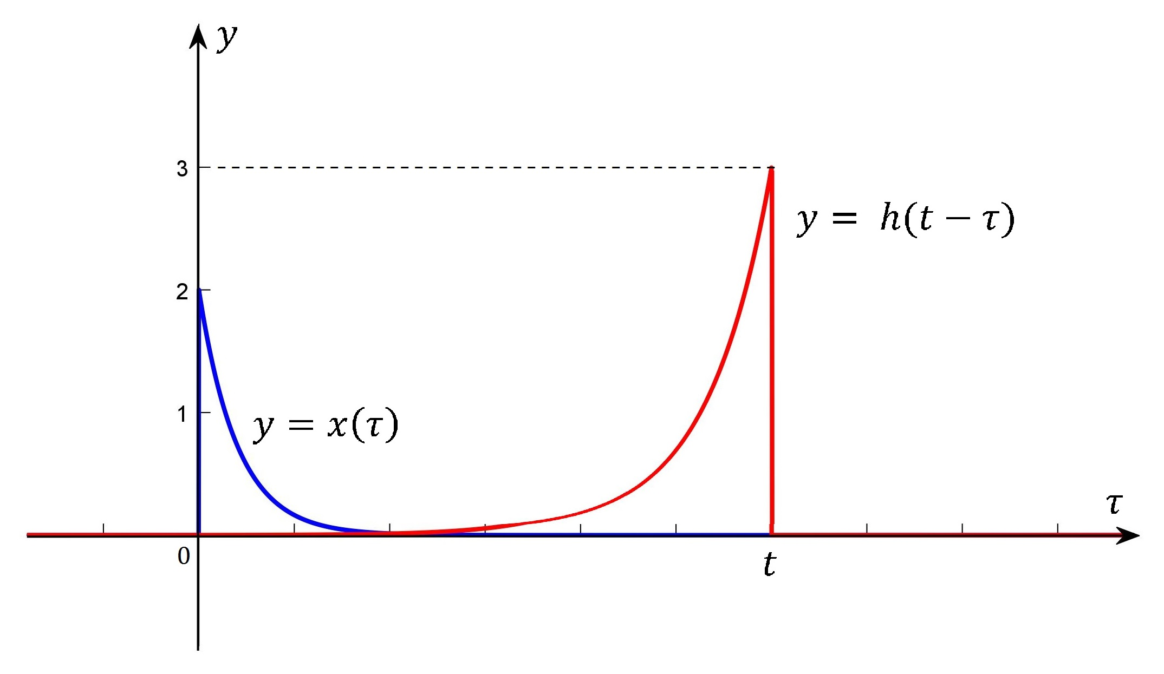

For $t<0,$ $x\left(τ\right)$ and $h\left(t-τ\right)$ does not overlap, $x\left(τ\right)h\left(t-τ\right)=0$ that leads to $y\left(t\right)=0$.

For $t≥0,$ the output becomes:

$$y\left(t\right)=\int_{-∞}^{+∞}{x\left(τ\right)h\left(t-τ\right)dτ}=\int_{0}^{t}{2e^{-4τ}.3e^{-2\left(t-τ\right)}dτ}$$

$$=6e^{-2t}\int_{0}^{t}{e^{-2τ}dτ}=10e^{-3t}{\left.\left(\frac{e^{-2τ}}{-2}\right)\right|}_{0}^{t}$$

$$=6e^{-2t}\left(\frac{e^{-2t}-1}{-2}\right)=3e^{-2t}\left(1-e^{-2t}\right)$$

Thus,

$$y\left(t\right)=\left\{\begin{aligned}0 , &t<0 \\ 3e^{-2t}\left(1-e^{-2t}\right), t≥0\end{aligned}\right.$$

b)

For $x_{1}\left(t\right)=2e^{-4t}u\left(t\right)→y_{1}\left(t\right)=\left\{\begin{aligned}0 , &t<0 \\ 3e^{-2t}\left(1-e^{-2t}\right), t≥0\end{aligned}\right.$

We have:

$$x\left(t\right)=e^{-4t}\left[u\left(t\right)-u\left(t-2\right)\right]=e^{-4t}u\left(t\right)-e^{-4\left(t-2\right)-8}u\left(t-2\right)$$

$$=\frac{1}{2}x_{1}\left(t\right)-e^{-8}x_{1}\left(t-2\right)$$

Due to the properties of LTI system, the output is given by:

$$y\left(t\right)=\frac{1}{2}y_{1}\left(t\right)-e^{-8}y_{1}\left(t-2\right)$$

$$=\left\{\begin{aligned}0 , t<0 \\ \frac{3}{2}e^{-2t}\left(1-e^{-2t}\right) , 0≤t<2 \\ \frac{3}{2}e^{-2t}\left(1-e^{-2t}\right)-3e^{-8}e^{-2(t-2)}\left(1-e^{-2(t-2)}\right), 2≤t\end{aligned}\right.$$

$$=\left\{\begin{aligned}0 , t<0 \\ \frac{3}{2}e^{-2t}\left(1-e^{-2t}\right) , 0≤t<2 \\ \frac{3}{2}e^{-2t}\left(1+e^{-2t}-2e^{-4}\right), 2≤t\end{aligned}\right.$$